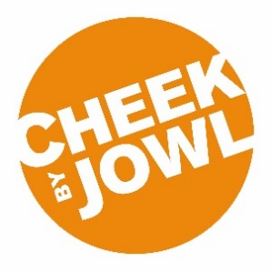
EQUAL OPPORTUNITIES IN EMPLOYMENT

Cheek by Jowl has an equal opportunities policy for recruitment and employment and welcomes applications from all sections of the community. We are committed to ensuring that all job applications and members of staff are treated equally, without discrimination. This form is to ensure that our equal opportunities process is working effectively.

All questions are optional. You are not obliged to answer any of these questions but the more information you supply, the more effective our monitoring will be. All information supplied will be treated in the strictest confidence and will not be used in any decision affecting you. It will not be placed on your personnel file.
Please tick the box next to the field with which you identify.
Gender
 | Male |  |  | Female
 | Prefer not to say

Gender identity
If you identify as transsexual, transgender (in that you have effected a permanent change of gender identity) or as intersex, which group do you identify with?
 | Transsexual |  |  | Transgender
 | Intersex
If you prefer to use your own term, please specify here:

Sexual orientation
 | Bisexual |  |  | Heterosexual/straight
 | Gay man |  |  | Other
 | Gay woman/lesbian |  |  | Prefer not to say
If you prefer to use your own term, please specify here:

Age
 | 0 - 19 |  |  | 50 - 64
 | 20 - 34 |  |  | 65+
 | 35 - 49 |  |  | Prefer not to say

Further questions overleaf.

Ethnicity
Ethnic origin is not about nationality, place of birth or citizenship. It is about the group to which you perceive you belong. Please tick the appropriate box.
White / White British |  | Mixed/multiple ethnic groups
 | British |  | White and Black Caribbean
 | Welsh |  | White and Black African
 | Northern Irish |  | White and Asian
 | Irish |  | Any other Mixed Background
 | Gypsy or Irish Traveller
 | Any other White Background
Asian/ Asian British |  | Black/African/Caribbean/Black British
 | Indian |  | African
 | Pakistani |  | Caribbean
 | Bangladeshi |  | Black British
 | Chinese |  | Any other Black Background
Any other Asian Background |  | Other
 |  |  | Arabic
 |  |  | Any other ethnic group
 |  |  | Prefer not to say
 |  |  | Don’t know
If you prefer to use your own term, please specify here:

Do you identify as a deaf or disabled person?
 | Yes |  |  | No
 | Don’t know |  |  | Prefer not to say

