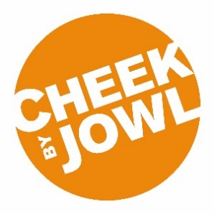
EQUAL OPPORTUNITIES IN EMPLOYMENT

Cheek by Jowl has an equal opportunities policy for recruitment and employment and welcomes applications from all sections of the community. We are committed to ensuring that all job applications and members of staff are treated equally, without discrimination. This form is to ensure that our equal opportunities process is working effectively.

All questions are optional. You are not obliged to answer any of these questions but the more information you supply, the more effective our monitoring will be. All information supplied will be treated in the strictest confidence and will not be used in any decision affecting you. It will not be placed on your personnel file.

Please tick the box next to the field with which you identify.
Gender
 | Male |  |  | Female
 | Non-binary |  |  | Prefer not to say

Age
 | 0 - 19 |  |  | 50 - 64
 | 20 - 34 |  |  | 65+
 | 35 - 49 |  |  | Prefer not to say

Sexual orientation
 | Bisexual |  |  | Heterosexual/straight
 | Gay man |  |  | Prefer not to say
 | Gay woman/lesbian

Ethnicity
White |  |  | Mixed
 | British |  |  | White and Black Caribbean
 | Irish |  |  | White and Black African
 | Gypsy or Irish Traveller |  |  | White and Asian
 | Any other White Background |  |  | Any other Mixed Background
Asian/ Asian British |  |  | Black/ Black British
 | Indian |  |  | African
 | Pakistani |  |  | Caribbean
 | Bangladeshi |  |  | Any other Black Background
 | Chinese |  | Other
 | Any other Asian Background |  |  | Arab
 |  |  |  | Any other ethnic group
 | Prefer not to say

Do you identify as a deaf or disabled person?
 | Yes |  |  | No
 | Don’t know |  |  | Prefer not to say

